Exercise 1.4

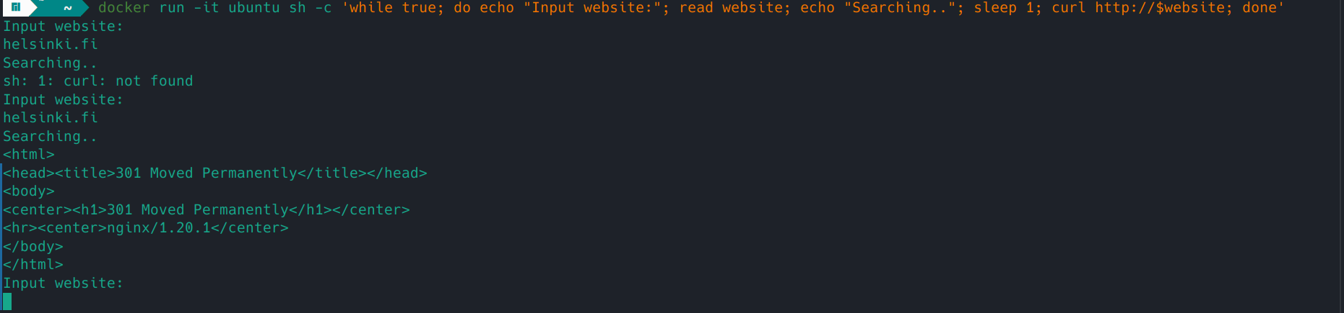

Installing curl command on the container via exec command

